Although the signal input ports of OpenBCI have TVS electrostatic protection chips, if the body parts with static electricity (mainly hands) directly touch the chip itself, then electrostatic discharge is likely to occur, which may cause the chip to malfunction. The chip is burnt, so it is recommended that body parts do not touch the chip on the module as much as possible. For example, grasp the edge of the PCB board when holding it by hand instead of holding it in your hand, and also prevent conductive impurities (metal shavings, etc.) from falling from the body parts. On the circuit, it should try to avoid direct contact with any components or exposed circuits.

OpenBCI Plastic Insulation Post Installation:

Note that this step can be ignored if it has been equipped with an insulating protective case

Look in the accessory package to see four pairs of plastic pillars (screws and studs). The plastic pillars can provide insulation and noise reduction, so please be sure to install them. The installation is relatively simple. There are Four 5mm fixing holes, just install the plastic pillars one by one:

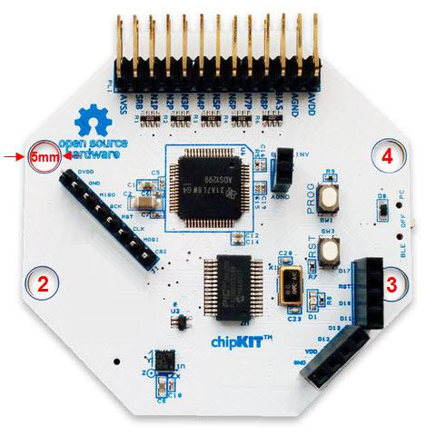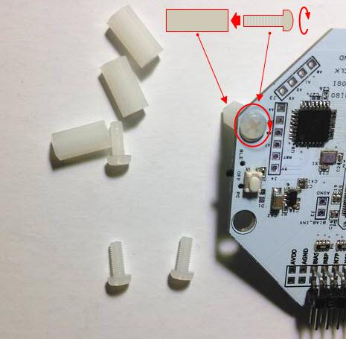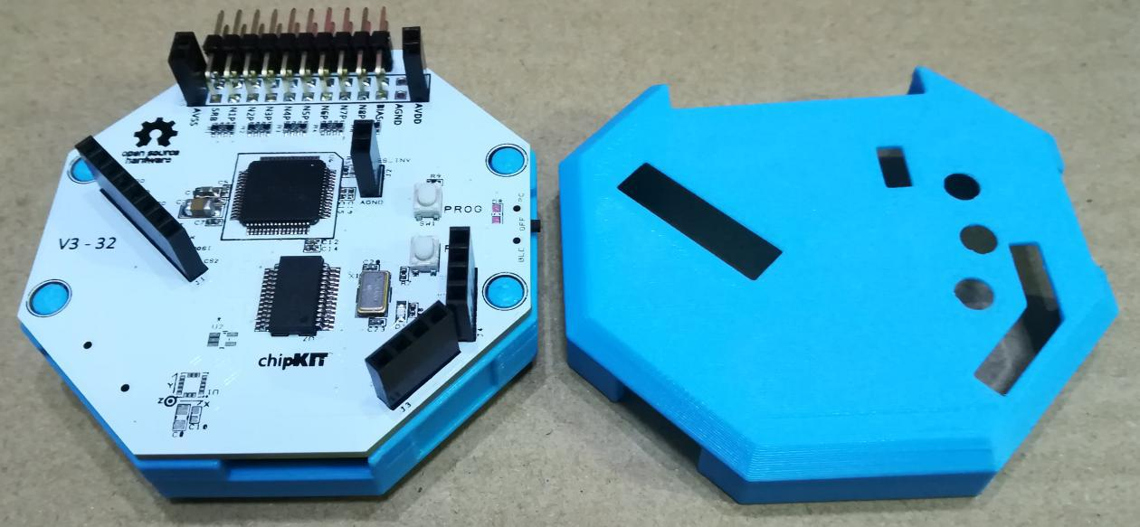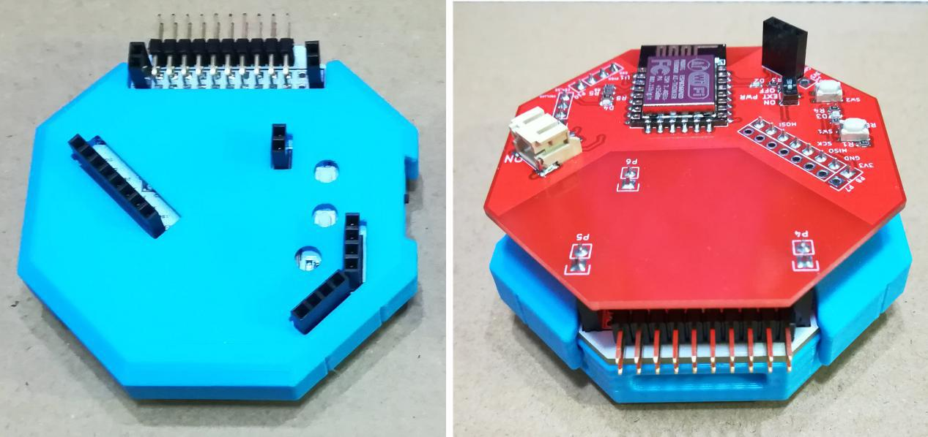

OpenBCI+WiFi Shield Assembly:

The following is the top view of the WiFi Shield. The A, B, C, D, and E labels are the fixing points of the WiFi Shield board and the OBCI board. Six-channel expansion board Daidy fixed point).

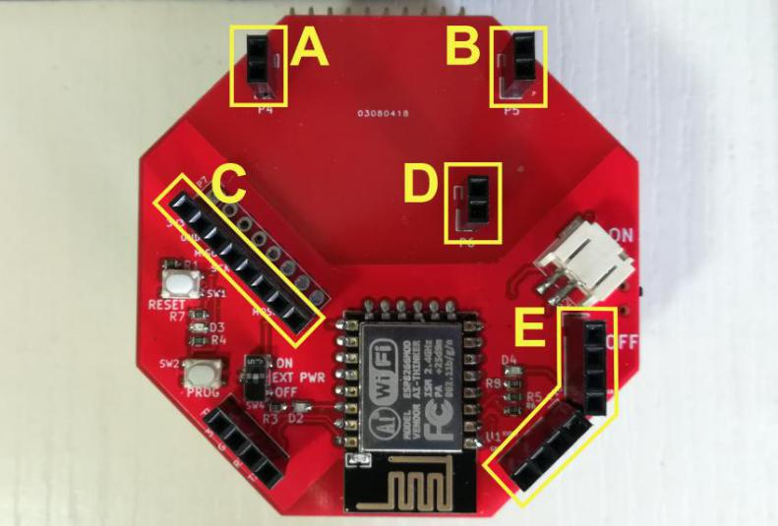

8-channel fixed schematic

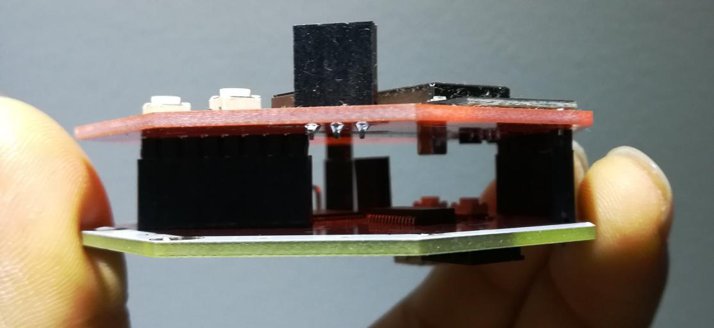

16-channel fixed schematic

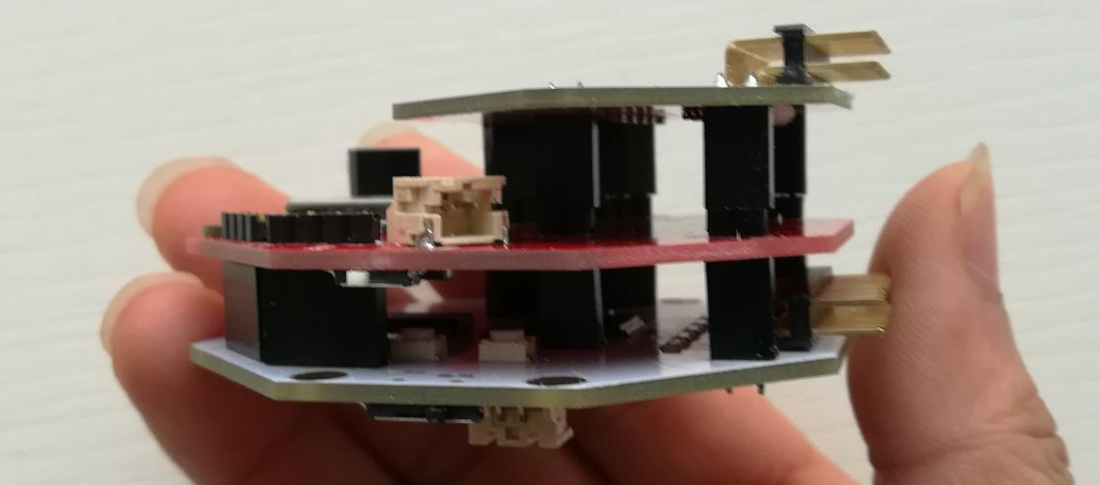

**OpenBCI powered**

1. Cyton power supply

Power supply is a very important part of EEG. The power supply line of OpenBCI consists of two high-quality wires, black is GND, red is VCC, and the recommended power supply range is 4V to 6V. The power supply of the adapter or charger, the power supply of the battery is relatively linear, there is no slight fluctuation, and there is no interference to the EEG. The normal adapter or charger or USB power supply of the computer (as long as the source is AC power) will be interfered by the power frequency. Domestic and European The power frequency is 50Hz, and the United States is 60Hz.

Common power supply options:

[1]. 6v-four dry batteries (recommended) [2]. 3.7v-lithium battery

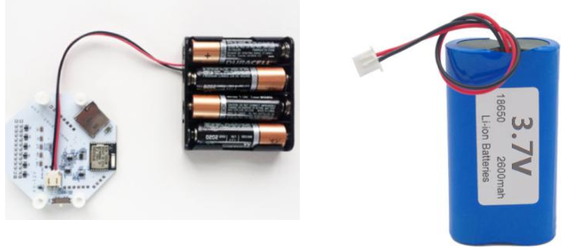

2. WiFi Shield power supply

The power consumption of WiFi Shield is relatively high, which can reach more than 80mA, so you need to choose a battery with strong energy storage, otherwise the use time will be short, which will affect the actual use

3. Cyton+WiFi Shield Hybrid Power Supply

Cyton and WiFi Shield are powered separately by default, but WiFi Shield can be set to supply power to Cython at the same time. The specific settings are as follows:

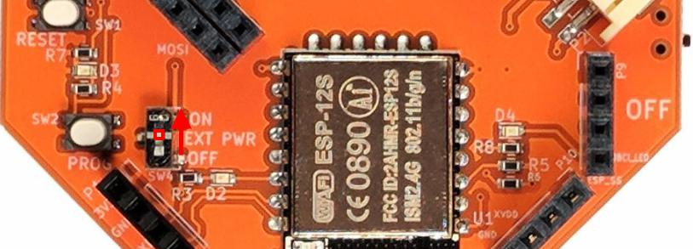

OpenBCI GUI data analysis software installation and verification

[1]. OpenBCI_GUI executable file

A. Network disk download (recommended)

Download the GUI software of the corresponding version of the system, and currently download the v3.3.2 version (official release in mid-2018) according to the provided network disk address.

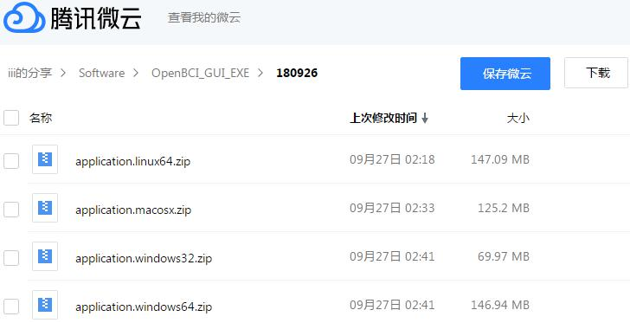

B. Download from the official website (not recommended, please refer to the "Note" below for the reasons)

Download the software of the corresponding version of the system from the official website, the address is as follows

<https://openbci.com/index.php/downloads>

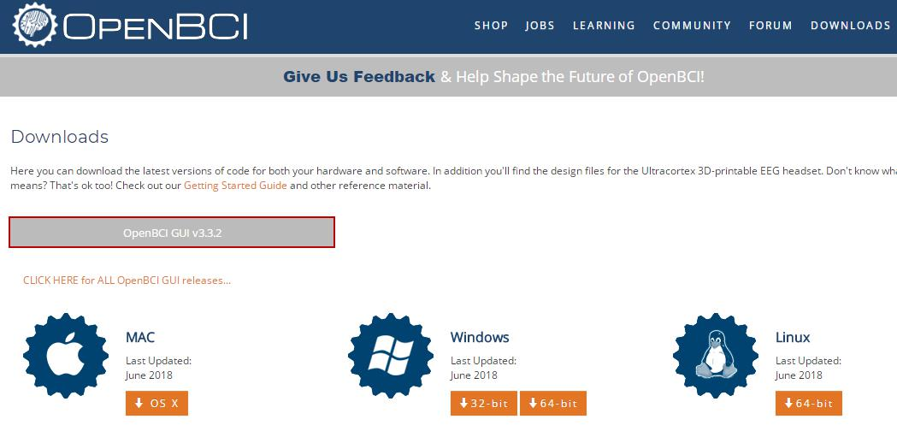

Note (must read): OpenBCI_GUI must be used in conjunction with the firmware burned by the corresponding version of the WiFi Shield board. If it does not match, it will lead to failure to search or to connect after searching, because the firmware version we burned in the WiFi Shield is currently v2. 0.5, and the corresponding GUI version is V3.3.2, but the version downloaded from the official website link will always be updated, so you can download it from the network disk. If you want to use the latest version of the official website GUI, you can update the WiFi Shield according to the official website manual. firmware

Here is an example of Win7 64bit system (how to view the system version information, refer to Appendix A at the end of the document), download

Windows 64-bit, the downloaded file is application.windows64.zip, after decompression is as follows:

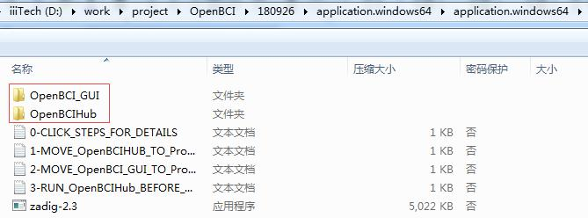

There are two main parts here: one is OpenBCI_GUI and the other is OpenBCIHub. OpenBCIHub is a communication bridge software. Only after OpenBCIHub is running, the acquisition board can be connected to the analysis software OpenBCI_GUI. Therefore, you need to run OpenBCIHub first, right-click OpenBCIHub as follows, and select "Run as administrator (A)"

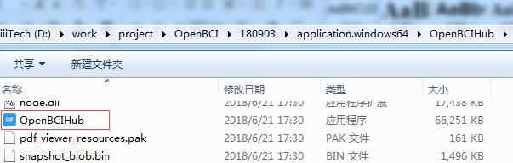

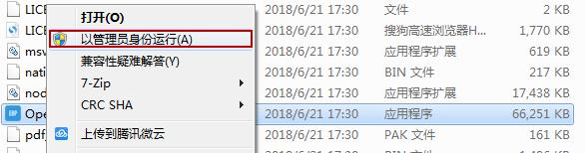

At this point, you can see the Openbci logo in the running program window in the lower right corner of the desktop as follows

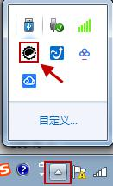

At this point, click on the logo to see the running status of OpenBCIHub (as shown in the figure below). If the following status pops up, it means that the operation is normal:



After OpenBCIHub runs normally, start the data analysis software OpenBCI_GUI, right-click as follows

OpenBCI_GUI, select "Run as administrator (A)"

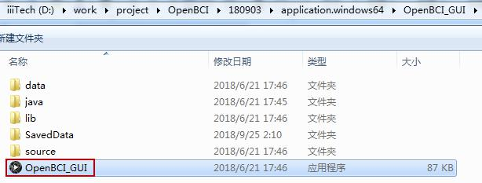

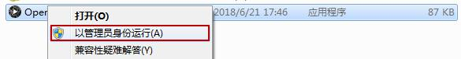

After running, you can see the following main interface, so far the analysis software has been installed

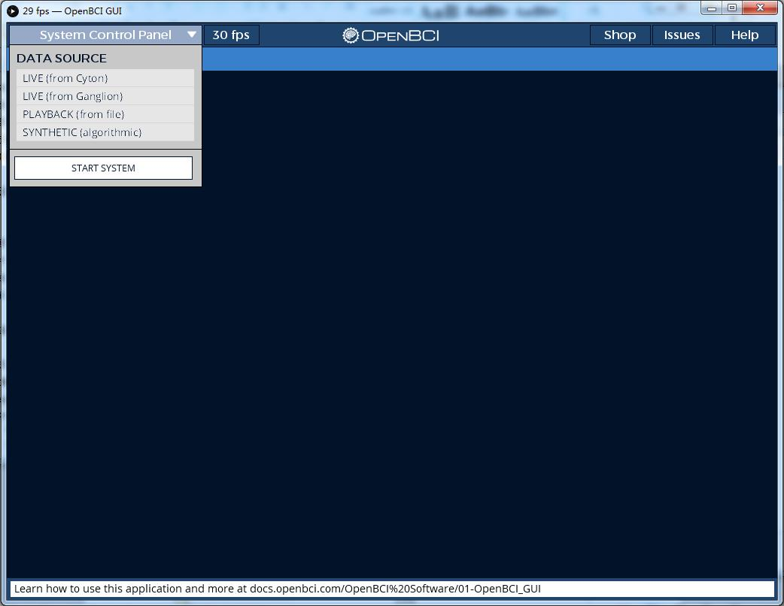

Note (must read): If the above interface cannot appear after running OpenBCI_GUI, or the following white/gray interface always appears, then it is recommended to

Step 1. Install the driver update related software (for example: driver wizard), scan the driver and update the graphics card driver, try the above steps again after the update, if the same is still the case after the update, then it is recommended to do

Step 2. Run directly by compiling the source code. For specific steps, please refer to the third section below (the executable file here).

OpenBCI_GUI.exe is an official executable packaged by compiling the source code, but everyone's computer environment is very different, including the officially packaged computer, there may be this incompatibility, which can be solved by compiling the source code).

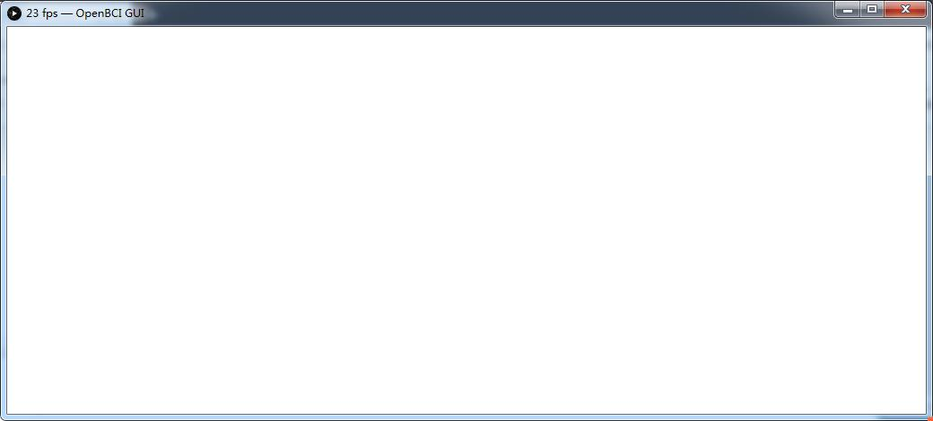

[2]. Start OpenBCI_GUI for data analysis

Note (required reading): Before starting OpenBCI_GUI, make sure that the WiFi Shield has been properly configured. If you choose a package that includes a configured router (the delivery note includes a configured portable router, the SSID/AP hotspot name is [iiiTech_OBCI] ], the password is [12345678]), then you can use it directly without configuring the connection parameters of the WiFi Shield board. If the package does not include a router or you want to replace the router, please prepare a router and configure WiFi according to "Appendix D" at the end of the manual Shield.

First make sure that the WiFi Shield and the computer have been connected to the same hotspot (here, iiiTech_OBCI is used as an example), and the computer can check the wireless connection status, as shown in the figure below, after the WiFi Shield is powered on for 10 seconds, check whether the LED2 flashes twice slowly (more about LED2 For details, please refer to "Appendix D" at the end of the manual), once a second, and then keep on.

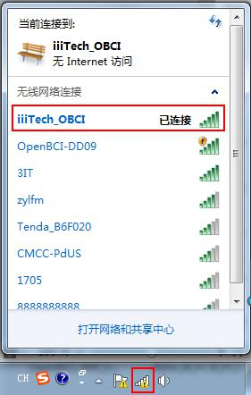

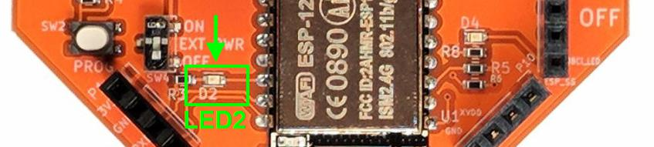

Note: To start data analysis, you need to install the WiFi Shield on the Cyton EEG acquisition board in advance after power off, then supply power to the WiFi Shield, and turn the following EXT PWR switch to ON, that is, through the WiFi Shield to the Cyton EEG acquisition board powered by:



After confirming that the computer and WiFi Shield are successfully connected to the same hotspot, open the WiFi software setting interface as shown below:

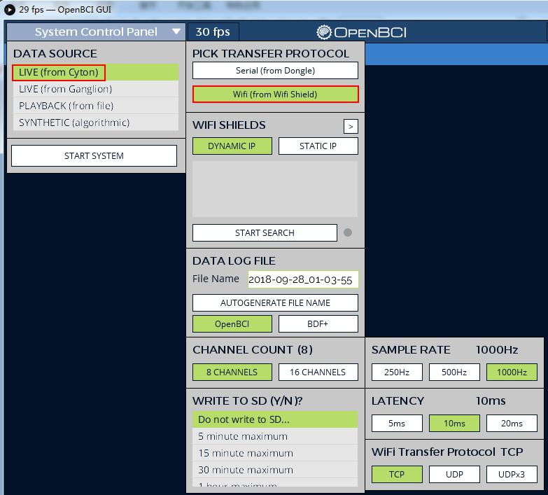

The red boxed part of the WiFi software setting interface as follows must be set correctly, otherwise it will affect the acquisition:

A is the channel selection. If an 8-channel expansion board (Daisy expansion board) is plugged in, that is, it becomes a 16-channel version, then "16 CHANNELS" must be selected, otherwise "8 CHANNELS" must be selected, otherwise it cannot be started;

B is the sampling rate setting, there are 250/500/1000Hz options, you can keep the default 1000Hz.

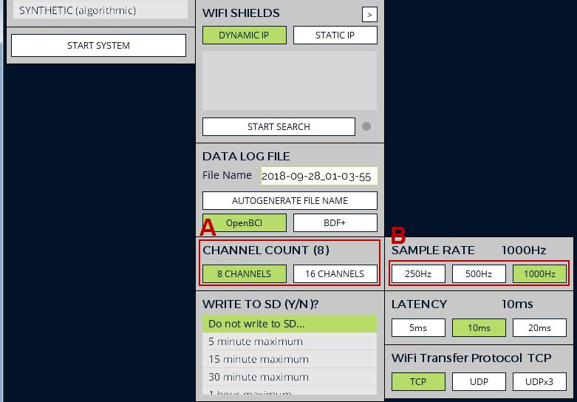

After all the above settings are completed, first search for the WiFi Shield board in the common local area network, and perform step A as shown in the figure below. Click "START SEARCH", and then the searched WiFi Shield ID will appear at the B mark, select the ID, and then execute the steps C, the "WIFI CONFIGURATION" box appears, then perform step D to obtain the information of the acquisition board, the acquired information can be seen at the mark E, after the above is successful, you can directly perform step F, that is, execute the connection with the Cyton acquisition board .

Note (must read): If you have performed the above step C, that is, the "WIFI CONFIGURATION" box will pop up and perform the subsequent D operation to obtain the Cyton information. Before starting the connection in the F step "START SYSTEM", remember to do it again Step A, that is, redo "START SEARCH", otherwise, it will not be possible to start step F after completing step C.

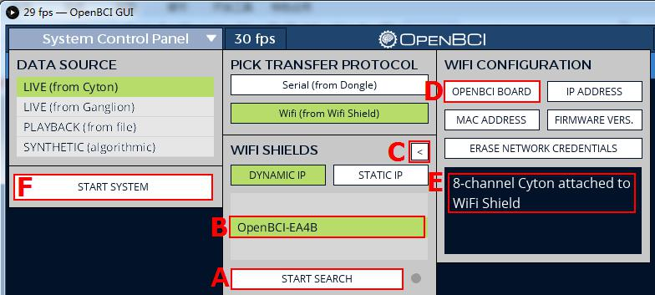

After the connection is successful, you can see the following interface, marked A~D respectively:

A: Data save location (by default it will be saved under SaveData in the software startup directory):

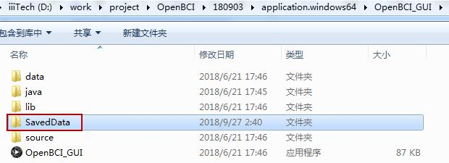

B: Start data collection button

C: Notch cut-off frequency, this is related to the power frequency (mains AC frequency) of each country, China is 50Hz, so you need to choose 50Hz

D: refers to the bandpass range, that is, the frequency range that can be filtered

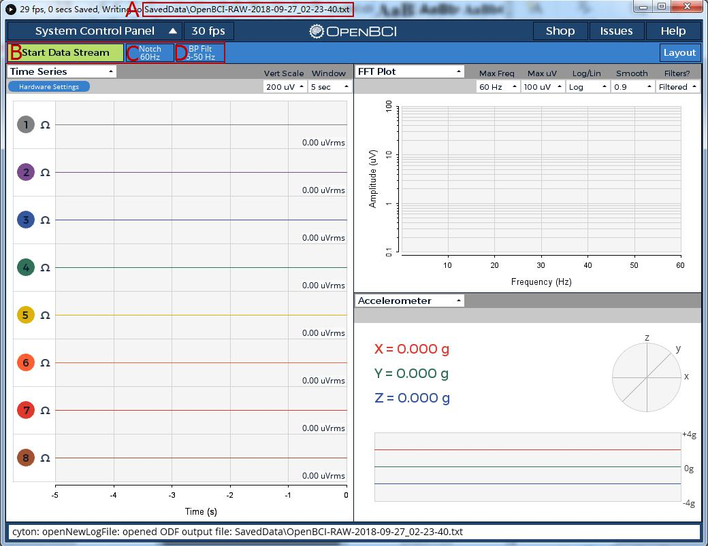

Click on "Start Data Stream

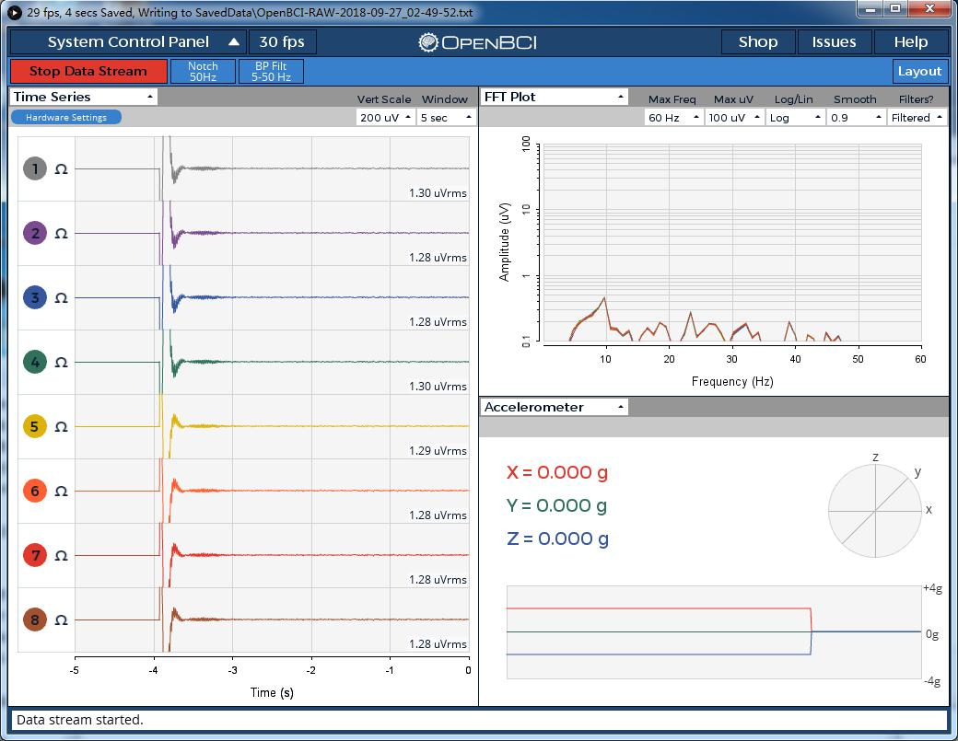

The connection between electrodes and EEG:

It is recommended to connect according to the software default configuration, that is, connect BIAS, SRB2 and the remaining 8 input channels

BIAS can be understood as a reference channel/REF. This BIAS is mainly used to reduce/reduce common mode interference, mainly environmental noise. The main frequency is 50Hz (power frequency), which is our commonly used alternating current, because the wiring and electrical appliances around us are all Contact with alternating current. For more information, please refer to the introduction of "Right Leg Drive"

SRB2 can be understood as ground/GND

1N~8N are 8 input channels

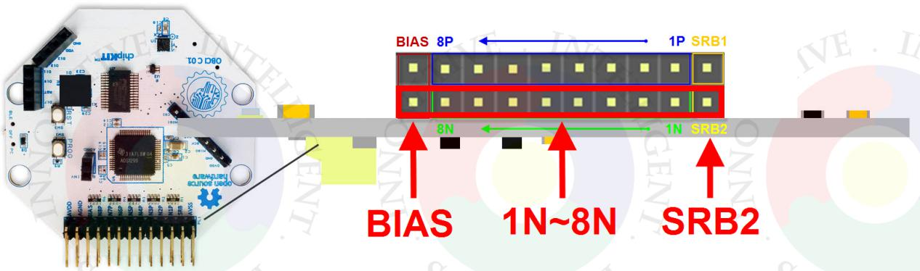

Take EEG as an example (refer to the diagram below):

Left and right ear connected to BIAS and SRB2 respectively

The rest of the acquisition channels are connected to any channel from 1N to 8N

